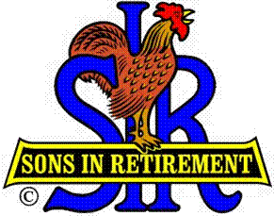**Las Trampas Branch 116**

**Luncheon Meeting Agenda**

**June 17, 2024, 11:30 AM**

**10:30** Social Hour

Greeters – Paul Ramacciotti, Joe Datz

New Member Orientation –

**11:25**  Five Minute Call

**11:30** Call to order – Big SIR

Pledge of Allegiance – Big SIR

Invocation– Terry Sherman

**11:30** Salad Served

**11:36** Storyteller – Mac McLoughlin

**11:42** Introduce Attendance of Speaker – FBI Agents Lester Kwok and Michael Roldan

* New Members - **Willie Brown**, Sponsor Jeff Johnson; **Robert Haber**, Sponsor “Photo Club”; **Michael Dimaggio**, Sponsor Rich Gerchow; **William McCa**nn, Sponsor, “Friend”
* Guest**: Dave Fiore**, Sponsor Scott Clark

**11:46** Activity Reports

* Carmel Golf Event – Phil Goff
* Activities - Mike Ward

**12:00** Lunch

**12:20** Introduce Speaker – Little SIR

**12:22** Speakers -  FBI Agents: Lester Kwok; Michael Roldan

**12:52**  Speaker Thank You – Big SIR

**12:25** Raffle Drawing – Bob Huck

Birthday Drawing – Little SIR

**12:35** Sing Happy Birthday

Sing God Bless America

**12:28**  Closing Remarks – Big SIR

**13:30** Adjourn; Next Meeting, July 15, 2024